Information Sheet

A young child should grow well and gain weight quickly. Regular weight gain is the most important sign that a child is growing and developing well. If children are undernourished for too long, they can be shorter in height for their age when they are adults.

Children must have enough of the right kind of food for healthy growth and to fight infection. Many children are not getting enough good food. There are many ways that health workers monitor the growth of children. Three of the simplest ways that can even be taught to older children include:
- Recognizing the signs of having too little food or too much of the wrong food.
- Weighing young children and recording their weight on a chart (don’t with adults at a clinic).
- By measuring the upper arm of children less than five years of age.
Children in Grade 5 and above can learn to understand why some children are undernourished, and how young children can be helped.

Weighing young children and recording their weight on a chart (don’t with adults at a clinic).
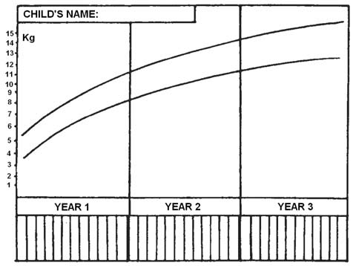
A good way to check if babies and young children up to the age of 18 months are growing (and eating) well is to weigh them regularly. Simple weighing scales are available in most countries. Health workers and parents can record the child’s weigh and mark it on a ‘road to health’ or ‘growth’ chart. The chart looks like this – see the road in the middle!

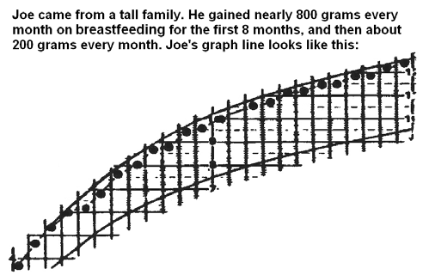
At each weighing the child's weight is marked with a dot on the growth chart and the dots should be connected. This makes a line that shows how well the child is growing. If the line goes up, the child is doing well. If the line is flat or going down – a health workers needs to give the family advice and keep a carful check on the health of the baby. If the child’s weight is marked regularly and he is eating well and growing well the health worker and parents will be able to see a steady increase in his weight like baby Joe in the chart below.

Not all children gain weight at the same rate and not all children weigh the same at birth. If a child’s parents are small then the child may also be small and weigh less than other children. He is not in danger if he continues to gain weight steadily, even though the weights are near or just below the bottom line of the ‘road’. Have a look at Sam’s chart below.

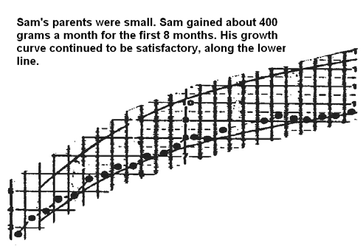

However, if the graph shows that the line does not rise, month by month, as the child gets older – or if the line drops due to an infection, and does not come up again quickly – then these are signs of danger. Like Abe’s chart below.
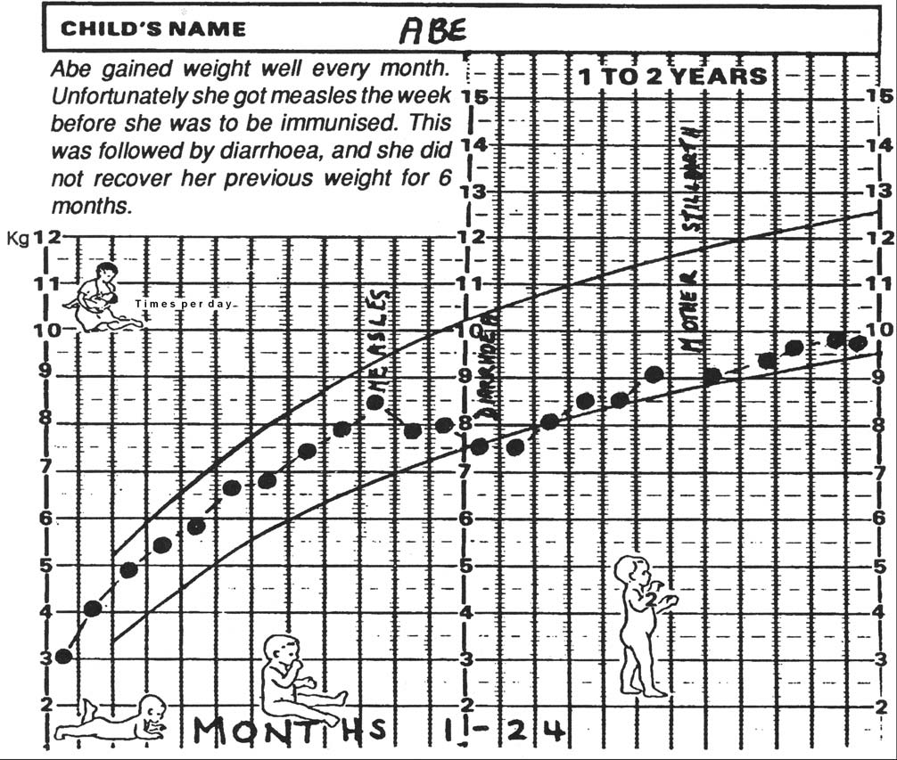
What are the reasons?
- Abe may have been ill and is not recovering quickly. He may be caught in the ‘circle of malnutrition’.
- Breastfeeding may have stopped. A lack of breast milk can often cause growth failure in the first six months of life.
- There may be a shortage of food
- Carers need more knowledge about how often to feed the child and the correct mixture of foods. If carers include children make sure children know how to do their duties well e.g. preparing and giving food using good hygiene and how often the children need to be fed
- Is the food being give to the child enough in volume but not enough in nutrition Foods such as mashed vegetables, a little chopped meat, eggs or fish should be added to the child's food as often as possible. A small amount of oil may be added, preferably red palm oil or another vitamin-enriched oil. Adding these items mean that a young child gets a lot of nutrition from a smaller amount of food.
- Do the carers know enough about what a young child is eating If meals are served in a common dish, younger children may not get enough food. Young children should have their own plate or bowl of food to ensure they can eat what they need and so the carer can see exactly how much they have eaten.
- Some young children need help to eat and in handling food or utensils. A child with a disability may need extra help eating and drinking.
- Sugary snacks or drinks that do not have vitamins and minerals cause children to loose appetite or gain too much weight without growth.

Weighing and measuring children from 18 months

After children are over the age of eighteen months, before they go to primary school, and during the time they are at school, they should continue to be weighed and measured.

Measuring arm circumference
Another way to recognizing whether children between one and five years old are undernourished is by measuring around their upper arms. The circumference – the distance around the arm – does not change very much during the first five years of life. Children can check this by feeling the arm of a five-year-old child and then that of a one-year-old child. In the one year-old there is fatter than muscle. In the five-year-old there is more muscle than fat. If a child is not growing properly, or losing weight, then the muscles do not grow and the arm circumferences less than normal. This is called ‘wasting’.

We need to measure the circumference of the arm halfway between the bony points of the shoulder and the elbow, using and arm circumference strip’. It is sometimes called the ‘Shakir Strip’ after the name of the doctor who first used it.
Making a Shakir Strip
The Shakir strip can be made from strong paper, thick plastic, or string, a strip from around aplastic bottle, or fiber from plants. It is important that the material does not stretch and this can be checked by pulling it beside a ruler. The strip should be about cm wide and about 40 cm long. Whatever material is being used, put a mark near one end (0), then at 5 cm, 12.5 cm, 13.5 cm and finally 20 cm from the 0 mark. It is very important to get the 12.5 cm and the 13.5 cm inexactly the right places. Then colour and mark the strip as shown.

Measuring using the strip
In healthy children, the measurement is more than 13.5 cm. When the strip is put around their arm, the zero (0) mark reaches the green part of the strip. If the zero (0) mark reaches the yellow part, the child is too thin. If it reaches the red part, the child is much too thin and may be undernourished.
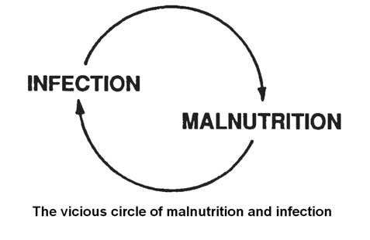
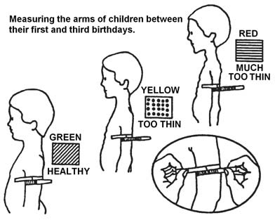

Monitoring growth in your area?
- How does the health clinic monitor the growth of the children in your village?
- Do mothers in your village use the growth charts?
- How do you feel about teaching children how to use growth charts and an arm circumference strip?

