CHILDREN FOR HEALTH Information Sheet on feeding babies and young children 0-12 months

Breast is Best!
Breast milk is the best natural food and drink for babies in their first months of life. It contains everything that babies need to grow well, and helps protect them against many diseases. A breastfeeding baby does not need water or anything else to drink before they are 6 months. Breast milk does not spoil for any reason. It is always fresh and at the right temperature and it has no germs in it. Breast milk is an amazing natural food and drink for baby as it changes a little each day to meet the exact needs of the baby that day. It changes from thick almost medicine-like yellow milk in the first few days to milk that is much thinner and has a much higher water content when the baby is older and needing more liquid.

Breastfeeding keeps mother and baby close. This closeness helps children develop as happy and secure. Breast milk helps baby’s body AND mind grow strong at a time when a baby grows very fast. Breast milk helps babies learn things faster.

Babies need to be able to suck, whenever they need a feed, day or night. Other people must support and help mothers do this. If a baby is breastfed whenever it needs a feed, there’s no need to give extra bottle feeds and risk diarrhoea and other illnesses.

When breastfed babies get iII, breast milk is the best food and drink for them and should never be stopped. It is even more important in helping recovery

Babies can be breastfed for two years or more but need extra food after 6 months.

When breastfeeding is difficult…
There are many pressures on mothers to bottle-feed their children instead. Some common problems that mothers and babies experience when first breastfeeding include:
- The child may need help to take more of the breast into the mouth.
- The child may need more frequent breastfeeding and possibly even 12 feeds during a 24-hour period. (The baby should suckle for at least 15 minutes).
- The child may not drink breast milk if they are unwell. In this case, they should be taken to a trained health worker.
In very unusual cases, if a mother has to stop breastfeeding, this should be done only on the advice of a trained health worker and a cup (not bottle) used to feed the baby.

Dangers!
If a mother gives the baby extra food or drink (like water on a hot day) this means the baby will not drink as much breast milk on that day and the milk supply can reduce for the next day. What baby needs most is breast milk. Water and the cups or bottles used to give baby drinks can be full of germs too.

Sometimes cow’s milk, powdered milk or other liquids are given to babies. These can be very dangerous for babies especially when powder is mixed with water that might not be safe. Cow’s milk and ‘formula’ (powdered milk for babies) are different from breast milk. Breast milk changes as the baby grows to meet her exact needs, powdered milk does NOT change.

Science shows that babies who are bottle-fed get ill and even die from diarrhoea more often than babies who are breastfed. They also get more chest infections. Bottles often contain germs that make a baby ill. If a feeding bottle is uncovered for a while, especially when its warm, germs can go on it and when the baby sucks on the bottle this can make baby ill.

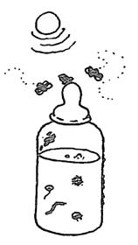
Colostrum = the BEST food and drink for new born babies
For the first few days after a baby is born, the mother’s breasts produce a special kind of milk called colostrum. Colostrum is yellow, and there is only a small amount of it. Colostrum protects the baby against germs that may cause diarrhoea and other infections. Sucking colostrum prepares both baby and mother for successful breastfeeding. There is no need to give extra drinks before the milk comes.

BE AWARE! Sometimes mothers are advised not to feed colostrum to their babies. This advice is incorrect!

Looking after Mother
While breastfeeding, mothers need lots of extra food and clean safe water and other nutritious drinks like juice, coconut water and herbal tea. This replaces the food and liquids she uses to make the breast milk. Breastfeeding mothers should not drink alcohol, tea or coffee. Breastfeeding mothers need more rest and a good diet. This helps mother make good milk. Mothers need extra help to rest and give new babies attention.

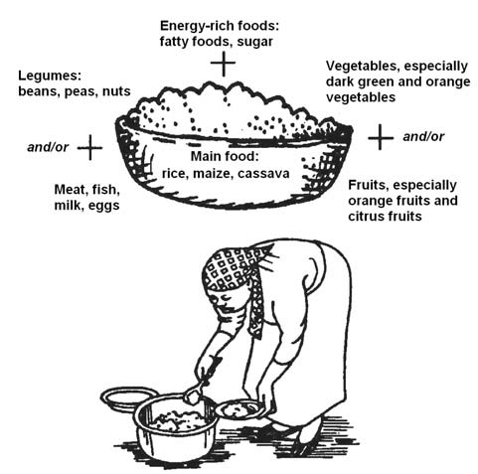
Introducing food from 6 months
After six months, a baby needs a variety of other foods in addition to breast milk to ensure healthy growth and development. Children’s food must provide them with enough of each kind of nutrient so that:
- They have energy to play, explore and learn.
- They can grow at a healthy rate.
- They can resist and fight infections and recover quickly from an illness

Start feeding babies with very soft foods and move slowly to thicker and more solid foods. Like all of us, baby needs lots of different types of foods for a balanced health diet. Remember that babies have small stomachs so they only need small amounts but they need feeding often.

When, How and How Much to Feed Baby
When | How | How much?
6-8 months | Mashed foods, thick soups and porridges | Start with 2-3 spoonful’s each meal and increase to half a cup each meal by 8 months. Give solid food two to three times per day and breast milk as often as baby needs.
6-8 months | Plus breast milk
8 -12 months | Semi-solid food or 'Finger foods' - that children can eat by themselves | 3-4 spoonful’s or half a cup or more (250 mls) at each meal  Three to four meals per day plus healthy snacks when the baby is hungry and wants this.
8 -12 months | Plus breast milk
8 -12 months | Plus healthy snacks (e.g. fruit or nut paste on bread)
12 months and older | Slightly softer foods moving to the same types of foods as the rest of the family | Three to four times per day -1/2 cup at each meal.
12 months and older | Plus breast milk or if the child is no longer breastfeeding give 1–2 cups of milk plus one or two extra meals each day | Three to four times per day -1/2 cup at each meal.

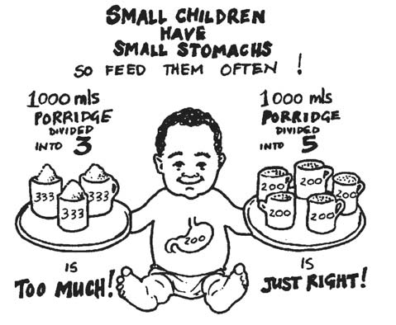

Ideas on WHAT to use to feed baby after 6 months
Staples | Rice, wheat, maize, millet, quinoa), roots (cassava, yam, potatoes) and starchy fruits (plantain and breadfruit)
Pulses | Chickpeas, lentils, cowpeas, black-eyed peas, kidney beans and lima beans. Iron in pulses and other plant food is best eaten with will foods high in vitamin C, such as oranges, other citrus fruits and juices.
Oils and seeds | Rapeseed oil, soy oil, red palm oil, butter or margarine.  Groundnut paste, other nut pastes and soaked or germinated seeds, such as pumpkin, sunflower, melon or sesame seeds
Meat and Dairy | Red meat, poultry, fish, liver and eggs (can be given as often as
Meat and Dairy | Cheese, yogurt, curds and dried milk (mixed with porridge).
Vegetables & Fruit | Green leafy and orange-coloured vegetables, such as spinach, broccoli, chard, carrots, pumpkins and sweet potatoes, bananas, mangoes, oranges, apples etc.

WARNING!
Avoid giving foods that may cause choking, such as nuts, grapes, raw carrots and other foods that may cause them to get stuck in the child's throat.

Extra nutrition
It’s sometimes difficult to give a young child all the nutrition they need. Also children on a vegetarian diet might need extra nutrition. They can get extra nutrition from special powder, syrup or tablet. These are called ‘supplement’. Trained health workers will advise families if they need to give these to baby and where to get them.

